**Geospatial Alert Framework for Maritime Borders Using Low-Power Wide Area Communication**

*Gunaseelan V*

Student/ ECE Velammal College of

Engineering and Technology,

Tamilnadu, India.

[gunaseelanv93@gmail.com](mailto:gunaseelanv93@gmail.com)

*Mr. G. Pradeep Kumar*

Associate Professor / ECE Velammal College of Engineering and Technology,

Tamilnadu, India

gpk@vcet.ac.in

*Dr. P. Suveetha Dhanaselvam*

Associate Professor / ECE

Velammal College of

Engineering and Technology,

Tamilnadu, India

psd@vcet.ac.in

*Dr. K. Kavitha, M.E., Ph.D.,*

Associate Professor / ECE Velammal College of Engineering and Technology,

Tamilnadu, India

[kkavi@vcet.ac.in](mailto:kkavi@vcet.ac.in)

*Govarthanan R*

Student/ ECE Velammal College of

Engineering and Technology,

Tamilnadu, India.

govarthananvenkatesh@gmail.com

*B. Karthikeyan, M. Tech*

Associate Professor / ECE Velammal College of Engineering and Technology,

Tamilnadu, India

[bkk@vcet.ac.in](mailto:bkk@vcet.ac.in%20)

*HariRaja P*

Student/ ECE Velammal College of

Engineering and Technology,

Tamilnadu, India

[hariraja2342@gmail.com](mailto:hariraja2342@gmail.com)

***Abstract— Small boat operators and accidental fishermen who cross over maritime boundaries has already emerged as a regular problem along coast. This work suggests low cost, easy to read and intelligent Blue Bound -Smart Ocean Border Security by GPS and Wireless Sync. The purpose of this is reducing such risks by virtue of real time geofencing as well as alerting functions. The software is developed upon Arduino Nano and makes use of NEO-6M GPS module in order to detect location, SX1278 LoRa transceiver in order to cater long range communication, as well as ESP8266 NodeMCU WiFi in such a way to sync up data over internet. The software is reliant upon pre-staged KML-format maritime boundary data linked to Google Maps in order to determine whether ship is in/near country borders or not. If ship advances towards/ over pre-set boundary, there is alarming (buzzer and LED) along with location will get transmitted over Wi-Fi (online mode) as well as LoRa (offline mode). This will keep up unit always ‘on’, even low connectivity zone/remote zone. The two-way voice communication software is more dependable to maintain surveillance over maritime borders. The fishermen, coast guards as well as maritime enforcement authorities of safety will get easy in deploying due to the fact that it is small in size, require very low power as well as will work under strenuous offshore conditions. The solution, by utilizing cheap as well as abundant hardware parts, enhances real time situational awareness as well as border protection to a large degree.***

1. INTRODUCTION

In sea nations such as India, where there are thousands of fishermen along with small boat handlers who involuntarily cross over international maritime boundaries, maritime boundary security is of utmost concern. Such kind of events has resulted in ROK detaining DPRK fishermen, vessels being docked as well as diplomatic tensions being raised. The commercial navigational equipment is too expensive or too complex to deploy at small scale, and cheap as well as appropriate solution is needed in order to tackle this issue. In order to discourage the problem of Unintentional Violations of Maritime Border Incursion whereby it gets into boundary automatically in recent times while floating, a microcontroller design under the name "Blue Bound – Smart Ocean Border Security Power by GPS +Wireless Sync" is introduced. In we calculate out current location of ship the system utilizes Arduino Nano microcontroller as being central processing unit along with NEO-6M GPS module. Displaying of such results is also executed by Google Maps so as to compare with what we have set as marine boundaries which we enter in using KML (Keyhole Markup Language). Also under this system, use of two communication modules are observed work in parallel in order to cover better different settings of network.

• Improved internet communication using WiFi by means of ESP8266 NodeMCU.

• Data transfer by utilizing SX1278 LoRa module with low power as well as long range.

LED as well as buzzer alert based alarm system alerts crew as ship approach(es) or crosses a virtual maritime boundary. LoRa and WiFi transfer capability guarantee that ship coordinates are sent in real time to a surveillance server or control unit. This inside or out of internet and cellular network capability guarantee safe tracking and notification of ship in remote sea environments. The real time alarm and power consumption which is very low of system best suitable to implement in small fishing vessels and in coast region surveillance. This project in this endeavour we attempt to suggest a low cost stand alone solution which increase fishman security, reduce cross border transgression and support automated marine surveillance at massive scale with minimal human interference.

# METHODOLOGY

The we use in this project is NEO-6M GPS module along with the Arduino Nano microcontroller that which we will be using for continuous boat location tracking. Also we will be putting in a feature to compare the collected GPS data with pre saved maritime boundary locations in KML (Keyhole Markup Language) format. At the same time also we will present these borders on Google Maps for easy visual identification of which maritime zone the boat is in. Also we have designed the system to work in 2 different communication modes to handle various connectivity issues.

**WiFi Mode (via ESP8266 NodeMCU):** The NodeMCU sets up WiFi connection and sends a boat’s real time GPS coordinates over to a Cloud based servers or online platforms if the internet is connected. This allows real-time tracking generating custom dashboards or Google maps integration, remotely monitorable by anywhere in the world by the authorities or the lawyer**.**

**LoRa Mode (using the SX1278 LoRa module):** With this mode, the System Shifts to LoRa (Long Range) as an alternative communication mode when WiFi or cellular networks get absent offshore or in low connectivity locations. The GPS information sent by the SX1278 module into the air goes to a distant base station on the coast. This ensures that there is constant flow of information and surveillance even in remote waters.

This system runs on 9V battery and therefore it is portable and suitable with small fishing boats. This removes the use of heavy or stationary power supply and installation is easy.

Checking the GPS coordinates considering the set KML boundaries with the help of Arduino microcontroller

Arduino microcontrollerArduino microcontroller

Location of boat via the GPS.

boat is close to sea border-activate alert system = buzzer + LED + transmit data via WiFi/LoRa to base station4.

Put location on the Google Map with KML integration | and keep it on guard till sailing continues

Fig 01: Flow of Methodology

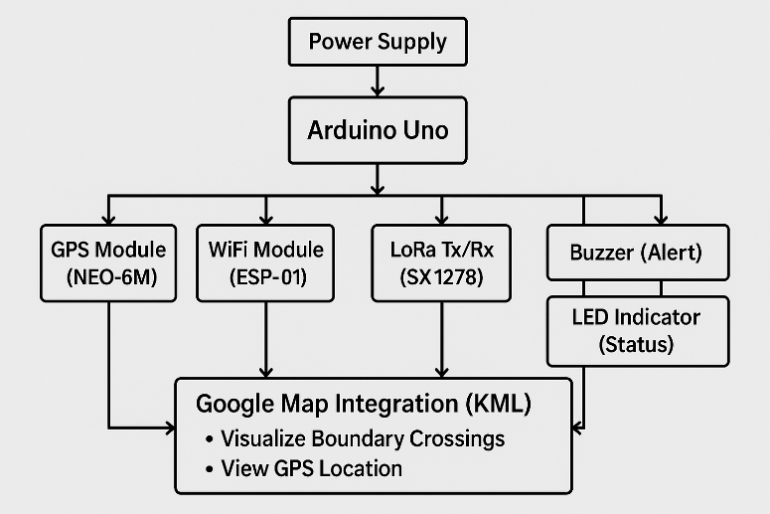

Fig 02: Block Diagram

# HARDWARE AND COMPONENTS DESCRIPTION

# *Arduino Uno*

## Arduino Uno is based on ATmega328P. The availability of both digital as well as analog input/output makes it compatible with numerous sensors and modules. Data broadcasted by GPS module is read by it, and data to output devices, like buzzer and LED, is transmitted by it as the core of the entire system. Furthermore, it also regulates communication with LoRa as well as WiFi module.

## Neo-6M GPS Module

The GPS is a satellite based navigation receiver which gives the latitude and longitude of the position of an individual. It sends the messages it gets through the satellites to the Arduino which in turn uses it as coordinates. This positional information is essential in determining the position of the vessel relative to the maritime boundaries; whether the ship is within or without the set limits.

1. *Module for LoRa*

LoRa Module is a wireless long-range, and a low power communication module based on the spread spectrum technology. It is used to coordinate the data and relay alert messages to remote monitoring stations without the mobile network, let alone using the internet. This comes in especially in the remote or oceanic settings.

## ESP8266/ESP32 WiFi Module

WiFi Modules typically are self-contained SoCs that have an integrated TCP/IP protocol stack, though they may have an integrated antenna rather than a connector, enabling them to join a WiFi network and be used to connect a microcontroller. When the internet connection is available, one utilises it to transfer the GPS data to a connected website like Google Maps and this provides a remote real-time tracking of vessels.

## The buzzer

This is an electronic device that produces sound when a current of electricity passes through it. In this system, it acts as an instant auditory alarm to the boat crew, and whenever it approaches or passes a boundary or limited area in the sea.

## The LED

A light-emitting diode used as a visual indicator is called an LED. In the event that ambient noise prevents the buzzer from being heard, it provides a prompt and conspicuous signal by blinking or lighting up to notify the crew when a border is crossed.

## The Power Supply (Energy Source)

All the connected components and the Arduino board must be supplied with power, i.e. by a power adapter or a 9V battery. It provides continuity of the systems in a continuous manner.

## Module for SD Cards

GPS location data can be stored locally with SD Card Module supporting. When in real-time communication is out of the question and data analysis needs to be performed at a later time, it can be useful.

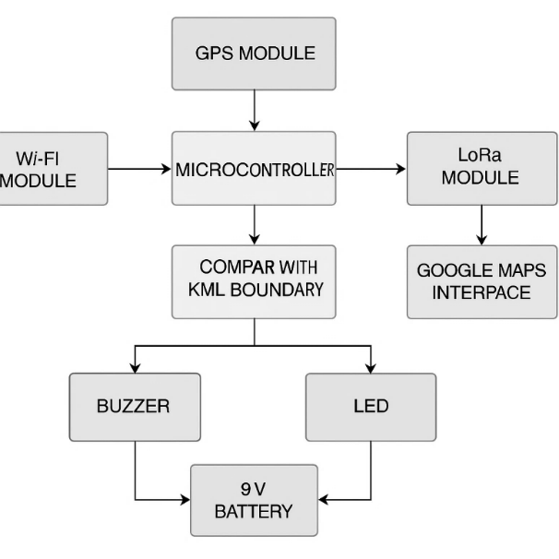

Fig 03: Assemble of Hardware components

# SYSTEM DESIGN AND RESULTS

The parameters that are to be calculated or monitored in order to ensure the system works efficiently are the following ones

## GPS settings

The GPS module always records the following parameters:

* Latitude in degrees Longitude (°):This gives the exact geographical location of the vessel.
* Speed (km/h or knots) is optional, This is the speed at which the vessel is travelling.
* Satellites locked: This shows how many satellites are connected, and this defines the accuracy of positioning.
* GPS Fix Quality: The quality of the GPS signal:
  + - 0 = Invalid
    - 1 = GPS fix
    - 2 = DGPS fix.

1. Calculating Distance

To determine how close the nautical border is the Haversine Distance Calculate the distance between:

* GPS position as of right now.
* The point nearest to the boundary of the KML file

*a = sin²(Δφ/2) + cos φ1 ⋅ cos φ2 ⋅ sin²(Δλ/2)*

*c = 2 ⋅ atan2(√a, √(1−a))*

*d = R ⋅ c*

Haversine formula for Calculating Distances

## Crossing Boundaries Verify

* Check to determine that the present situation is of an in or beyond the polygon kml.
* Use of GPS boundary zones or the Point-in Polygon (PIP) algorithm.
* if in the outdoors, sound an alarm..

## GPS Fix Time

* The duration that is required to receive a GPS signal.
* Total length of time involved in border monitoring (distance of trip).

## Signal Status (Success/Failure) of LoRa Transmission

* The WiFi connectivity status.
* The alert trigger's status (LED/buzzer ON/OFF).

## Warning Levels

* The range that a warning is issued at (such as within 100 meters of the frontier).
* In order to avoid spamming on the buzzer, repeat the alert frequency and delay.
* The setup of the system was finally done and tested successfully but with good outcome with the given looped coordinates.

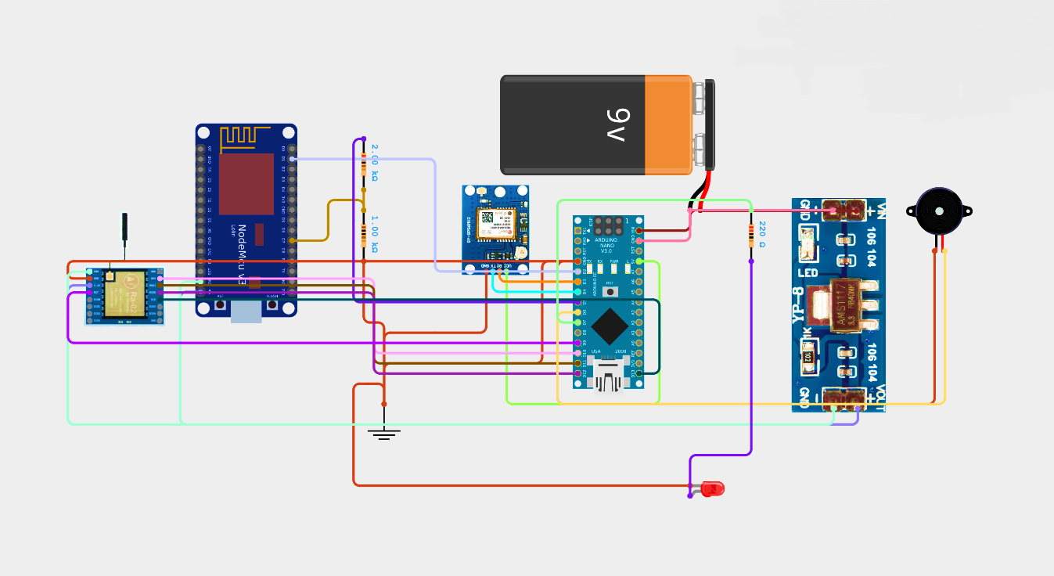

*Fig 04: Overall Circuit Diagram*

## 

](https://www.google.com/maps/d/edit?mid=1lwhUjiQ55FKkP-vuQxFGYtOicAtp_nM&usp=sharing)

## Fig 05: 16 predefined GPS coordinates between Sri Lanka & India

This map is used to depict the predetermined 16 GPS positions that are the maritime boundary acted upon in the WiFi and GPS-Based Maritime Border Alert System between India and Sri Lanka. These are the geofencing points with the help of which one can determine the position of the boat and also receive alerts so that the boat does not approach the border and cross it.

Fig 06: (9°14′51″N, 79°30′32″E) Gulf of Mannar

It is positioned on 9º14”51 N and 79º30’32’’E at the Gulf of Mannar between the south eastern cost of Tamil Nadu, India and the northwestern cost of Sri Lanka. It is one of the maritime areas that boasts its biodiversity and is widely engaged in fishers. Its location is in the coordinates very close to the Indo-Sri Lankan maritime boundary but within the Indian waters. This region is important in order to keep a track of fishing activity, and to make sure that the fishermen do not intrude into the Sri Lankan territory.

*Table 1: Performance Calculation and Analysis*



Fig 08: LoRa shows more success as distance increases, compared to WiFi where the results decline drastically as the point extends. Fig 10: Time of operation builds with distance and it reaches a maximum at point 10 as it drops because

Fig 09: Accuracy cannot be good when distance increases, but will be better again when compared to stable coverage areas.

Fig 11: Accuracy cannot be good when distance increases, but will be better again when compared to stable coverage areas.

Fig 12: Boat Position Detection system

It is used in this block diagram in which the Boat Position Detection system compares this to predefined KML maritime boundaries. Once the boat crosses the boundary, the alert module will trigger a buzzer and LED as well as shipping data to a remote map interface such as Google Maps through the LoRa/WiFi to be real-time monitored.

Fig 13: Real-Time Maritime Border Alert System

# CONCLUSION

In our case, WiFi and GPS-based Maritime Border Alert System is quite effective in making the maritime operations way safer because maritime security is always a matter about location tracking via GPS and getting a real time alarm when it is in the vicinity of international boundaries. The combination of both LoRa and WiFi-based dual communication guarantees the high packet success rates, a short response time and a reliable alert accuracy in even the most distant sea areas. This is confirmed as efficient in protecting fishermen and avoiding accidental crossing of borders as there is field analysis conducted based on 16 strategic coordinates.

REFERENCES

1. S. Rathinavel and D. Sridharan, GPS and GSM based Boat Navigation and Border Alert System, International Journal of Engineering Trends and Technology (IJETT), vol. 45, no. 3, 2017, pp. 123127.
2. K. Maurya, P. Singh and S. Pal, Design and Implementation of a LoRa Based GPS Tracker in a Coastal area, International Journal of Recent Technology and Engineering (IJRTE) vol. 8, no. 6, pp. 4082-4086, Mar. 2020.
3. S. Kumar, S., and V. Aggarwal, Real-time tracking and alert system using GPS and GSM, International Journal Of Computer Applications, vol. 62, no. 22, p. 3539, Jan. 2013.
4. D. P. Tewari and A. S. Kesarwani, Smart location tracker of fisherman with LoRa and GPS, International Conference on Smart Systems and Inventive Technology (ICSSIT), pp. 1-5, 2022.
5. Google Maps Platform Documentation, [Internet]. Available.
6. M. I. M. Hossain, M. Hasan, M. R. Islam, and M. M. Rahman,Design and Implementation of a smart Maritime Border Alert System Using GPS and GSM, 2015. International Journal of Computer Applications, May 2019, vol. 178, no. 18, pp. 1217.
7. J. Gubbi, R. Buyya, S. Marusic, and M. Palaniswami, Internet of Things (IoT): A Vision, Architectural Elements, and Future Directions, Gerard Thorne Future Generation Computer Systems, vol. 29, no.7, pp. 16451660, Sep. 2013.
8. M. Centenaro, L. Vangelista, A. Zanella and M. Zorzi, Light Reading, (31 January 2019), Long-Range Communications in Unlicensed Bands: The Emergent Stars in the IoT and Smart City Prospect. Ieee Wireless Communications, (2016).
9. H.Karland, A.Willig, Wireless Sensor Networks,Protocols and Architectures.